ADITYA MISHRA

STATISTICAL INFERENCE

MATH-3316-003

MINI PROJECT #1

1. Use SAS codes explained in class to redo Example 1.14 page 14 in our class book 9th ed, using the summary steps to make frequency distribution, introduced in class. Plot the histogram with midpoint in the middle of each class and the counts on top of the bar. Label your axis and title your plot.

a. Code for Histogram with Counts on top

b. Results from the output.

c. Histogram representation of the distribution of IQ

1. Plot the histogram with midpoint in the middle of each class and the percent on top of the bar. Label your axis and title your plot.
2. code for Histogram with percent on top

1. Histogram representation of the output.

1. Access the following URL https://documentation.sas.com/doc/en/pgmsascdc/9.4_3.5/procstat/procstat_ univariate_examples.htm. Mimic examples 4.28 and 4.29 in the above address to reproduce Figure 1.31 in example 1.47 page 68 in our class book 9th edition.

a. code for qqplot of the time

1. Quantile-Quantile plots shown below.

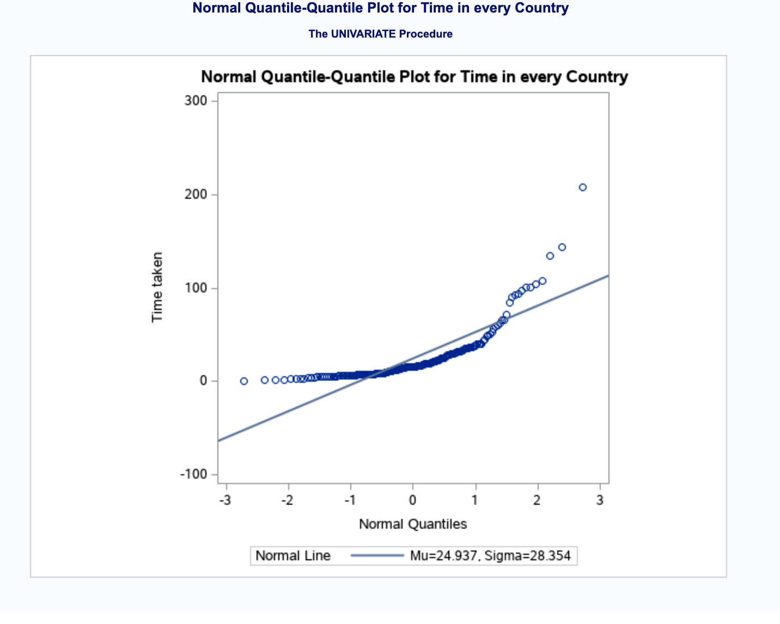

1. ) Write comments, findings, and conclusions on graphs of problems 1-3, describe in a small paragraph each plot.

Ans: Comments findings and conclusions of above graphs are written below:

1. Above histogram, in number one shows a better representation of IQ of students. It shows IQ of students based on counts which means how many numbers of students have IQ between a certain range. For example: 16 students have a between 105-115. The histogram looks more of a symmetrically distributed.
2. Above histogram, in number two shows a better representation of IQ of students in terms of percentage. It shows IQ of students based on percent which means how many percent of students out of 100 have IQ between a certain range. For example: 26.7 % have a between 105-115. The histogram looks more of a symmetrically distributed.
3. The qq plot or quantile-quantile plot shown in number 3 is non-symmetric in nature. The curvature is more like convex curved which means it is right skewed.